Polynomial and Rational Functions Name _________________________
A2RCC U8D6 Homework

Exercise #1: Combine each of the following fractions by first finding a common denominator. Express in simplest form.

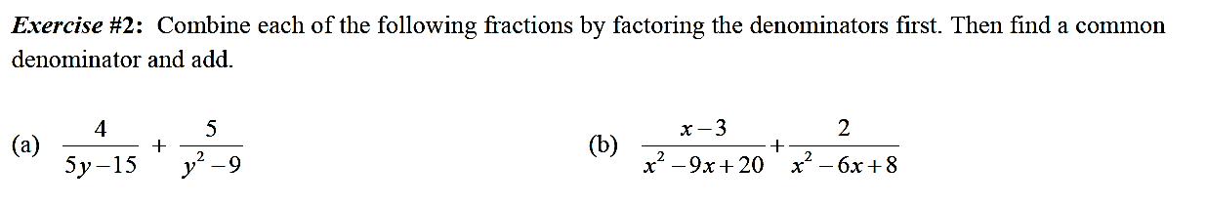

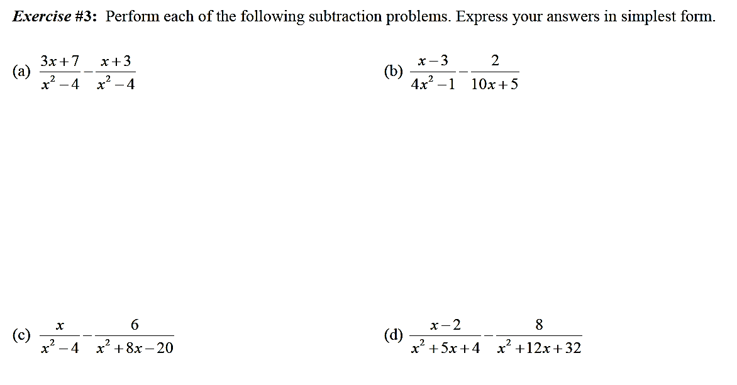

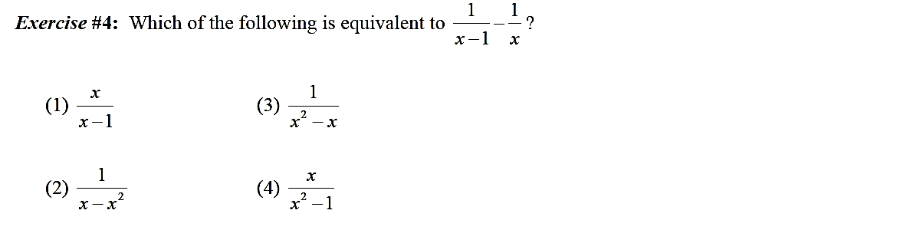

Regents Questions

5) Simplify: $\frac{a^{4}-b^{4}}{a^{2}-2ab+b^{2}} × \frac{a-b}{a^{2}+ab}$

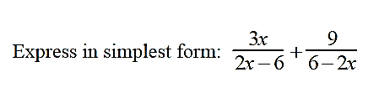

6)

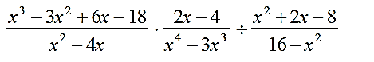
7) Perform the indicated operations and simplify completely.

